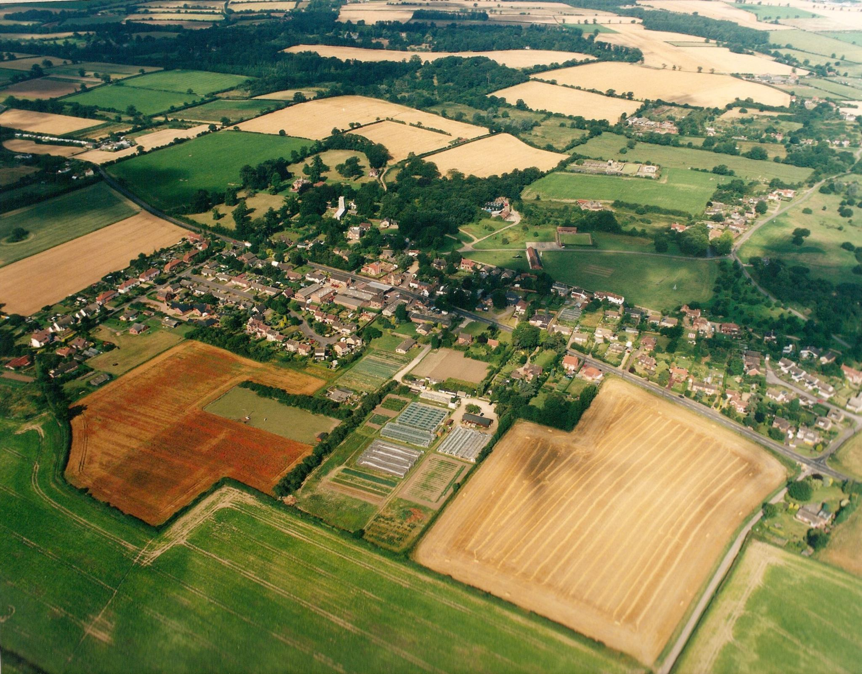

✹

# 7:30pm at Swardeston Village Hall

# on

**Annual village meeting**

# Everyone is welcome come along and find out what is happening in your local community

## Refreshments from 7.00pm

18th may 2017

✹